Subsection 1: Start-up Expenses

DESCRIPTION:

Expenses for the first month based on what we require to initialize our business plan.

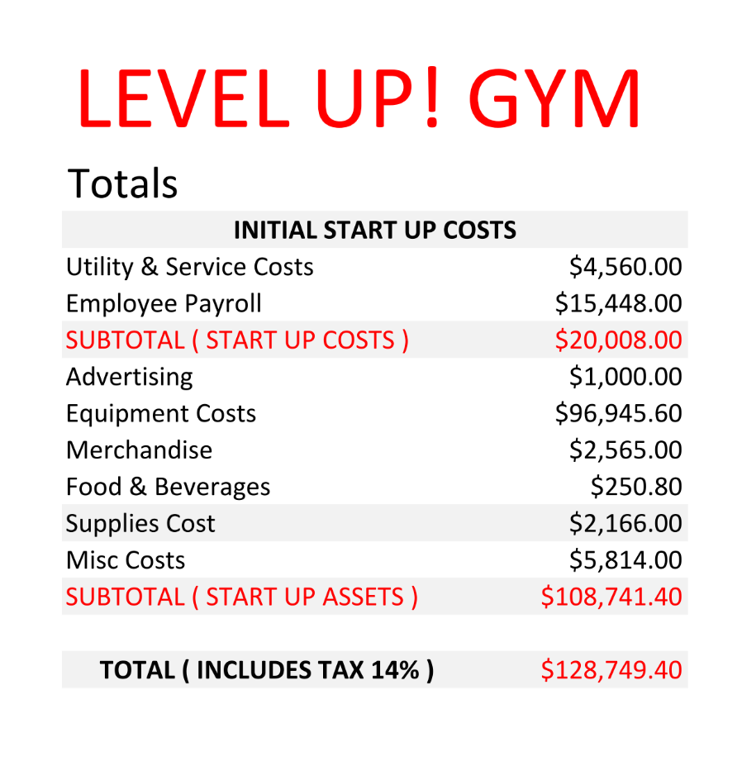

Subsection 2: Start-up Assets

DESCRIPTION:

Our list of assets, including their quantity, cost and subtotals.

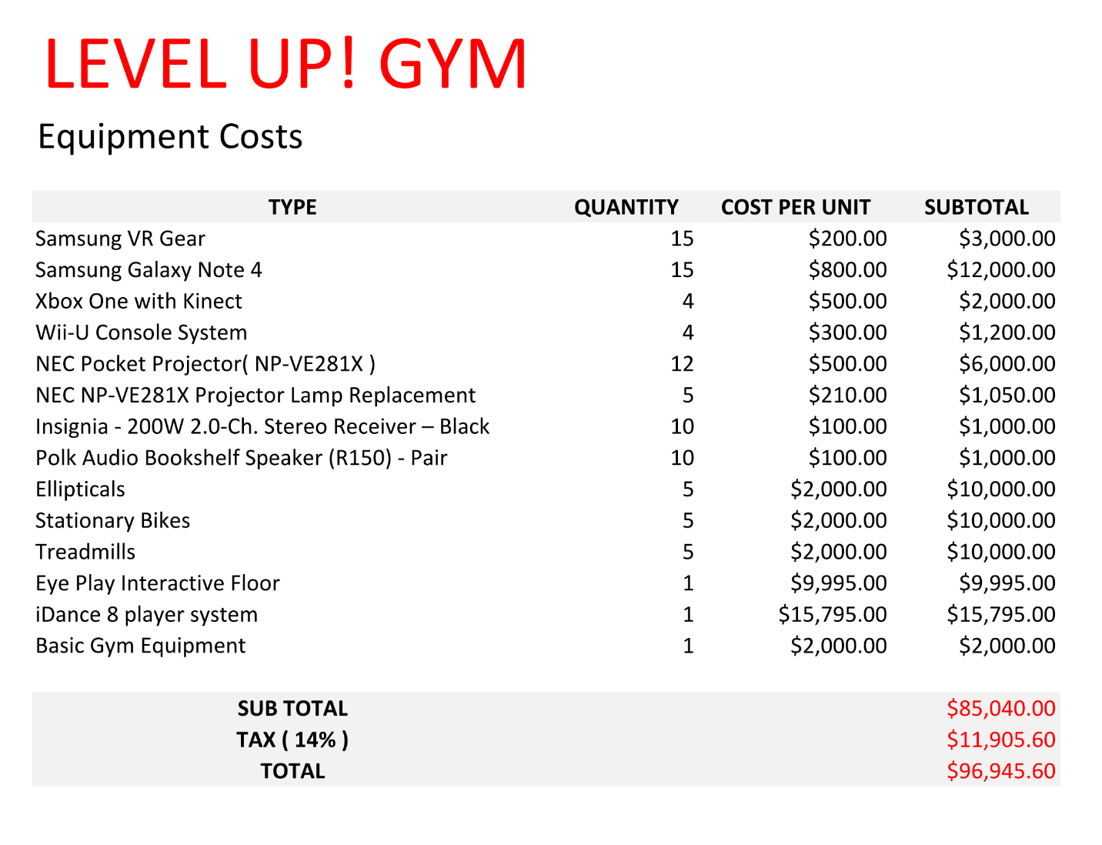

Subsection 3: Source and Use of Funds

DESCRIPTION:

Level Up! Gym will start with 4 founders. Each will be supplying $15,000 to the start-up costs. This will give us $60,000. Our loan requirement would be an amount equaling $80,000.

Our use of the funds are highlighted in the tables for expenses and assets required. To start off we need a large amount of money to go into buying the equipment necessary to begin the gym. The start-up month will be, by far, the most expensive month we will need because of this. The following months will require some purchases of equipment but not nearly as much as the beginning, meaning our expenses per month will be cut by half or more following the first month.

Subsection 4: Break-even Analysis

DESCRIPTION:

Currently we are making a predicted $18262.58 per month of profit. After the first month we are estimating monthly expenses to be roughly $20,008.00.

The first five years show no profit earned although the amount decreases substantially based on increased profits from a larger customer base. We see that in our 6th year of operation we will receive a positive profit margin.

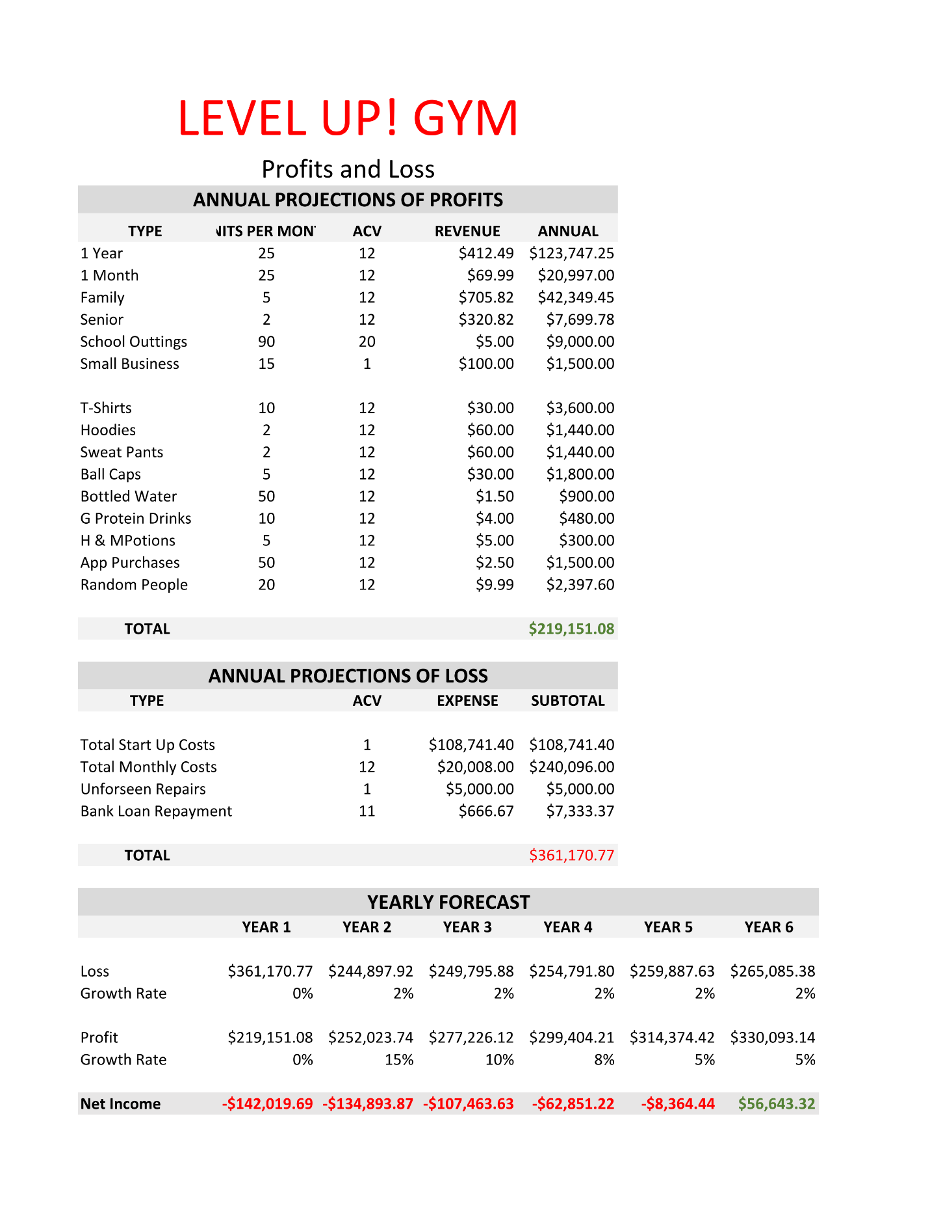

Subsection 5: Profit and Loss

DESCRIPTION:

This section describes our projected profits and losses over a 5 year span. Moving through Year 2 – Year 5 you can see that we will have an estimated increase in each category by a percentage amount. The projected loss will also increase, but is more stable as service companies increase their pricing yearly. We project that our percentage may drop off after the third year due to less hype regarding the business overall and customer base should be established by that time with a firm amount. Net profit was found by calculating how much was made total – the costs for that year.

ACV – Annual Conversion Vector

Converts all values to an annual state.

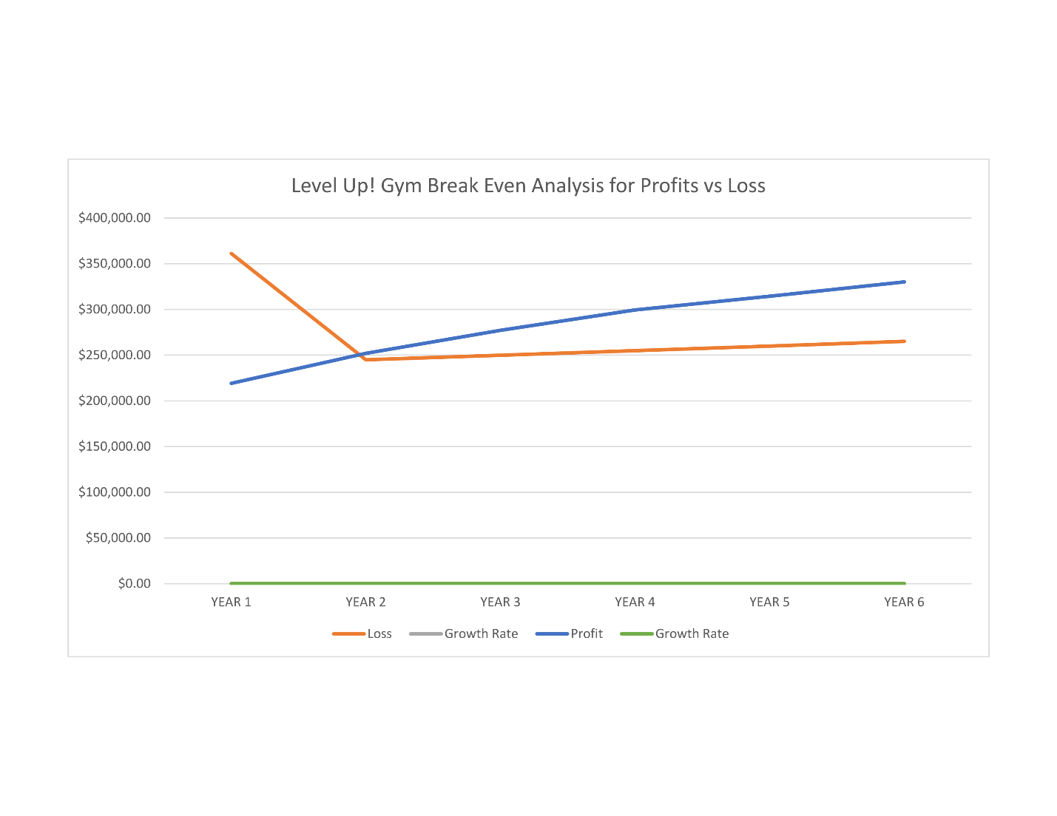

Subsection 6: Balance Information

DESCRIPTION:

Assets:

We will be beginning with $150,000 and will be making an estimated $235,000 that year. This will give us cash assets of $385,000 to work with that year as a total figure.

A large portion of this will be used for long term assets which includes, gym equipment, gaming related equipment, and furniture for the lobby.

Short term assets include office supplies and merchandise which will be sold in-store and online from our website.

Liabilities:

Upon receiving financial aid for our start-up costs, our current plan is to pay at a rate of 5% interest over a 10 year period. Below we list our amortization payment schedule for a loan. This is calculated with the minimal financial amount to allow us to start.

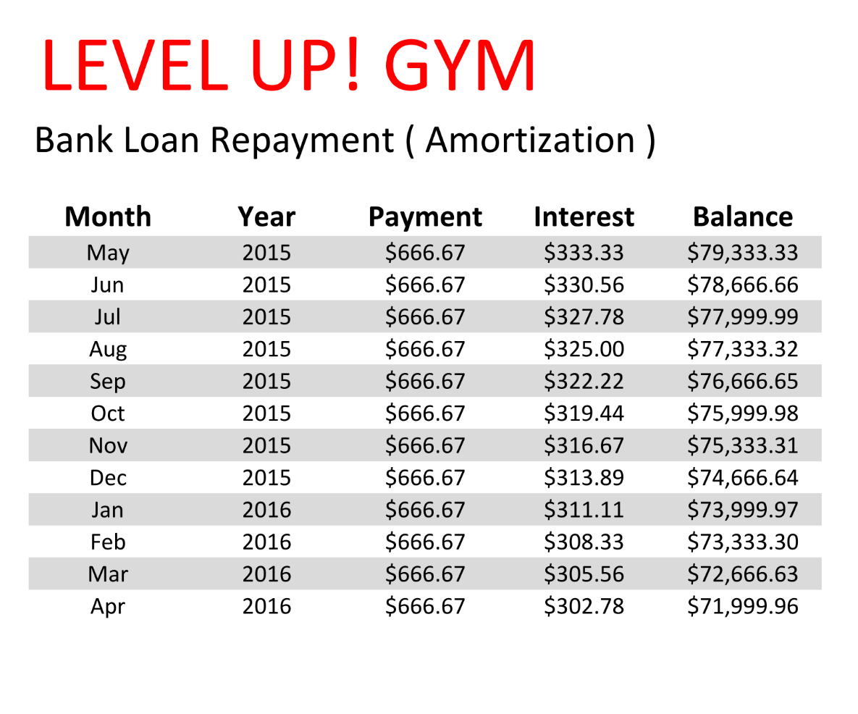

Subsection 7: Budget Sheet

DESCRIPTION:

Listed below is a graph representation of our monthly budget for a one year span. Costs are estimated to be similar month to month, as there is no large variation in service costs.

